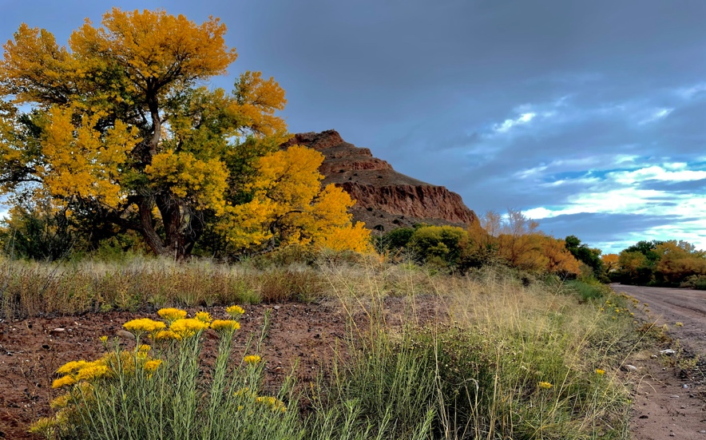
New Mexico Painting Workshop
Oct. 17-24, 2026-Instructor-Glen Kessler

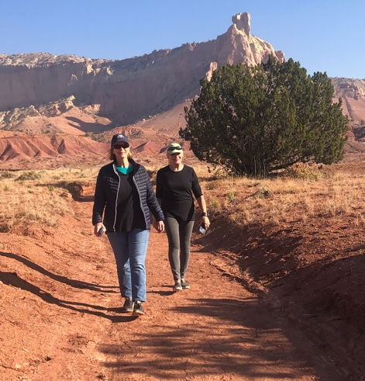
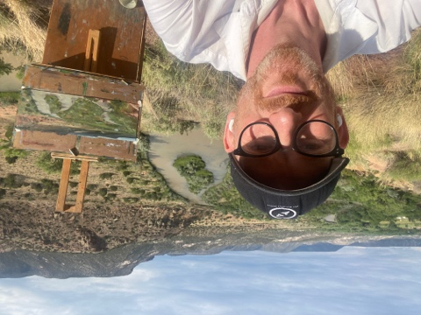
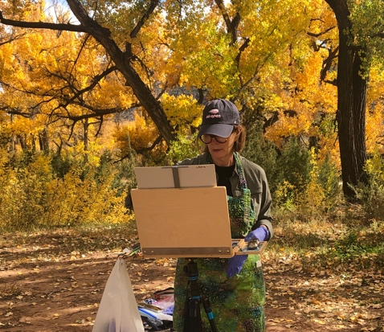
Join us on this painting journey to the land of Join us enchantment, New Mexico. This week in October, the cottonwoods in the valley turn an incredible golden hue. It’s a special time and this ranch is a unique place. This will be our 7th workshop here!

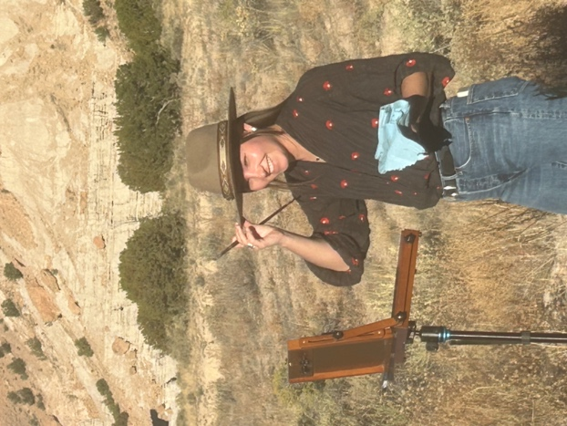
Your instructor is Glen Kessler, founder and owner of the Compass Atelier in Kensington, MD. He will instruct in all aspects of plein air painting, such as your equipment, studying values, composition and color mixing. He’ll show you how to capture the magical light that New Mexico is famous for. This is Glen’s 3rd workshop at the ranch!

Unpack and relax as we stay all week at this elegant and comfortable ranch near Abiquiu with views of the Chama river running right through the property. You can literally see the golden cottonwoods from the dining room table and porch. There are endless views to paint right from the ranch.

Visit nearby Ghost Ranch for a private tour to see many of the actual sites that Georgia O’Keefe painted and then at the conclusion, we have time to paint in an arroyo as well!
We will also enjoy a day trip to visit the galleries in Santa Fe.

Workshop includes: 7 nights lodging on a private ranch, all transportation (including airport pickups and drop-offs in Albuquerque and Santa Fe), breakfast daily, plus either lunch or dinner daily, sightseeing fees and art instruction. Airfare is not included. $3500 per person double occupancy. Non-painting companion rate $3100 per person double occupancy. More info. can be found on the website or contact josievosoba@gmail.com with questions.
www.lavenderandvine.net

